Lampiran 1
HASIL TES DAN PENGUKURAN
TINGGI BADAN DAN BERAT BADAN
NO | NAMA | TINGGI BADAN (cm) | BERAT BADAN (kg)
1 | SFN | 154 | 65
2 | NP | 166 | 57
3 | EM | 164 | 51
4 | ANP | 150 | 50
5 | VLVP | 166 | 65
6 | DAP | 151 | 55
7 | I IST | 165 | 62
8 | VAB | 160 | 50
9 | AAZ | 150 | 51
10 | YAEP | 155 | 44
11 | ADF | 157 | 57
12 | NMH | 160 | 51
13 | CEFA | 164 | 51
14 | APP | 155 | 45
15 | AA | 153 | 50
16 | RYES | 151 | 53
17 | NPDS | 185 | 55
18 | LAW | 168 | 70
19 | AIAS | 166 | 70

Lampiran 2
HASIL TES DAN PENGUKURAN
KEKUATAN OTOT LENGAN
NO | NAMA | PUSH-UP 30 detik | KETERANGAN
1 | SFN | 30 | BAIK
2 | NP | 26 | CUKUP
3 | EM | 19 | SEDANG
4 | ANP | 24 | CUKUP
5 | VLVP | 30 | BAIK
6 | DAP | 23 | CUKUP
7 | I IST | 35 | BAIK
8 | VAB | 25 | CUKUP
9 | AAZ | 26 | CUKUP
10 | YAEP | 10 | KURANG
11 | ADF | 29 | BAIK
12 | NMH | 35 | BAIK
13 | CEFA | 16 | SEDANG
14 | APP | 25 | CUKUP
15 | AA | 26 | CUKUP
16 | RYES | 25 | CUKUP
17 | NPDS | 28 | BAIK
18 | LAW | 28 | BAIK
19 | AIAS | 27 | BAIK

Lampiran 3
HASIL TES DAN PENGUKURAN
KEKUATAN OTOT PERUT
NO | NAMA | SIT-UP 30 detik | KETERANGAN
1 | SFN | 31 | BAIK
2 | NP | 30 | BAIK
3 | EM | 30 | BAIK
4 | ANP | 20 | SEDANG
5 | VLVP | 26 | BAIK
6 | DAP | 25 | BAIK
7 | I IST | 30 | BAIK
8 | VAB | 28 | BAIK
9 | AAZ | 28 | BAIK
10 | YAEP | 27 | BAIK
11 | ADF | 30 | BAIK
12 | NMH | 30 | BAIK
13 | CEFA | 30 | BAIK
14 | APP | 25 | CUKUP
15 | AA | 29 | BAIK
16 | RYES | 22 | CUKUP
17 | NPDS | 25 | CUKUP
18 | LAW | 25 | CUKUP
19 | AIAS | 26 | BAIK

Lampiran 4
HASIL TES DAN PENGUKURAN
POWER OTOT TUNGKAI
NO | NAMA | VERTICAL JUMP (kg.m/dtk) | KETERANGAN
1 | SFN | 53,06 | SANGAT BAIK
2 | NP | 41,17 | BAIK
3 | EM | 47,74 | BAIK
4 | ANP | 36,00 | CUKUP
5 | VLVP | 59,80 | SANGAT BAIK
6 | DAP | 52,71 | SANGAT BAIK
7 | I IST | 58,04 | SANGAT BAIK
8 | VAB | 40,68 | CUKUP
9 | AAZ | 38,25 | CUKUP
10 | YAEP | 34,57 | CUKUP
11 | ADF | 41,45 | BAIK
12 | NMH | 39,16 | CUKUP
13 | CEFA | 39,87 | CUKUP
14 | APP | 33,75 | CUKUP
15 | AA | 51,06 | SANGAT BAIK
16 | RYES | 38,80 | CUKUP
17 | NPDS | 46,95 | BAIK
18 | LAW | 46,67 | BAIK
19 | AIAS | 55,00 | SANGAT BAIK

Lampiran 5
HASIL TES DAN PENGUKURAN
KELINCAHAN
NO | NAMA | SHUTTLE RUN (detik) | KETERANGAN
1 | SFN | 13,43 | BAIK
2 | NP | 14,25 | SEDANG
3 | EM | 13,47 | BAIK
4 | ANP | 13,76 | BAIK
5 | VLVP | 14,95 | SEDANG
6 | DAP | 13,13 | BAIK
7 | I IST | 13,09 | BAIK
8 | VAB | 13,90 | BAIK
9 | AAZ | 15,22 | SEDANG
10 | YAEP | 14,88 | SEDANG
11 | ADF | 13,03 | BAIK
12 | NMH | 17,05 | KURANG
13 | CEFA | 14,82 | SEDANG
14 | APP | 12,97 | BAIK
15 | AA | 12,92 | BAIK
16 | RYES | 13,83 | BAIK
17 | NPDS | 14,06 | BAIK
18 | LAW | 14,52 | SEDANG
19 | AIAS | 13,97 | SEDANG

Lampiran 6

HASIL TES DAN PENGUKURAN
KECEPATAN
NO | NAMA | SPRINT 30m (detik) | KETERANGAN
1 | SFN | 7,03 | KURANG SEKALI
2 | NP | 7,31 | KURANG SEKALI
3 | EM | 7,25 | KURANG SEKALI
4 | ANP | 7,28 | KURANG SEKALI
5 | VLVP | 7,61 | KURANG SEKALI
6 | DAP | 7,53 | KURANG SEKALI
7 | I IST | 7,03 | KURANG SEKALI
8 | VAB | 6,84 | KURANG SEKALI
9 | AAZ | 7,63 | KURANG SEKALI
10 | YAEP | 7,72 | KURANG SEKALI
11 | ADF | 7,38 | KURANG SEKALI
12 | NMH | 8,43 | KURANG SEKALI
13 | CEFA | 6,97 | KURANG SEKALI
14 | APP | 7,00 | KURANG SEKALI
15 | AA | 7,25 | KURANG SEKALI
16 | RYES | 7,41 | KURANG SEKALI
17 | NPDS | 7,62 | KURANG SEKALI
18 | LAW | 7,77 | KURANG SEKALI
19 | AIAS | 7,34 | KURANG SEKALI
Lampiran 7
HASIL TES DAN PENGUKURAN
VO2Max
NO | NAMA | MFT | KETERANGAN
1 | SFN | 33,90 | CUKUP
2 | NP | 27,80 | SANGAT KURANG
3 | EM | 33,60 | CUKUP
4 | ANP | 28,80 | KURANG
5 | VLVP | 31,90 | CUKUP
6 | DAP | 31,20 | CUKUP
7 | I IST | 31,90 | CUKUP
8 | VAB | 33,60 | CUKUP
9 | AAZ | 33,30 | CUKUP
10 | YAEP | 30,90 | KURANG
11 | ADF | 35,60 | BAIK
12 | NMH | 35,30 | BAIK
13 | CEFA | 32,60 | CUKUP
14 | APP | 39,90 | SANGAT BAIK
15 | AA | 41,20 | SANGAT BAIK
16 | RYES | 32,60 | CUKUP
17 | NPDS | 31,90 | CUKUP
18 | LAW | 27,40 | KURANG
19 | AIAS | 37,60 | BAIK

Lampiran 8

DESKRIPTIF PER VARIABEL
Descriptive Statistics
 | N | Minimum | Maximum | Mean | Std. Deviation
KEKUATAN OTOT LENGAN | 19 | 10,00 | 35,00 | 25,6316 | 5,91806
Valid N (listwise) | 19

Lampiran 9

Descriptive Statistics
 | N | Minimum | Maximum | Mean | Std. Deviation
KEKUATAN OTOT PERUT | 19 | 20,00 | 31,00 | 27,2105 | 3,04738
Valid N (listwise) | 19

Lampiran 10

Descriptive Statistics
 | N | Minimum | Maximum | Mean | Std. Deviation
POWER OTOT TUNGKAI | 19 | 33,75 | 59,80 | 44,9858 | 8,06575
Valid N (listwise) | 19

Lampiran 11

Descriptive Statistics
 | N | Minimum | Maximum | Mean | Std. Deviation
KELINCAHAN | 19 | 12,92 | 17,05 | 14,0658 | 1,02336
Valid N (listwise) | 19
Lampiran 12

Descriptive Statistics
 | N | Minimum | Maximum | Mean | Std. Deviation
KECEPATAN | 19 | 6,84 | 8,43 | 7,3895 | ,37001
Valid N (listwise) | 19

Lampiran 13

Descriptive Statistics
 | N | Minimum | Maximum | Mean | Std. Deviation
VO2Max | 19 | 27,40 | 41,20 | 33,2105 | 3,62459
Valid N (listwise) | 19

Lampiran 14
Z Score
No | Z Push Up | Z Sit Up | Z Power Tungkai | Z Shuttle Run | Z Sprint | Z MFT
1 | ,73815 | 1,24352 | 1,00105 | -,62128 | -,97153 | ,19022
2 | ,06225 | ,91537 | -,47309 | ,18001 | -,21479 | -1,49273
3 | -1,12057 | ,91537 | ,34147 | -,58219 | -,37695 | ,10745
4 | -,27570 | -2,36614 | -1,11407 | -,29881 | -,29587 | -1,21683
5 | ,73815 | -,39723 | 1,83668 | ,86403 | ,59601 | -,36157
6 | -,44467 | -,72538 | ,95766 | -,91443 | ,37979 | -,55469
7 | 1,58302 | ,91537 | 1,61847 | -,95351 | -,97153 | -,36157
8 | -,10672 | ,25907 | -,53384 | -,16200 | -1,48504 | ,10745
9 | ,06225 | ,25907 | -,83511 | 1,12786 | ,65006 | ,02469
10 | -2,64134 | -,06908 | -1,29136 | ,79562 | ,89330 | -,63746
11 | ,56918 | ,91537 | -,43837 | -1,01214 | -,02560 | ,65924
12 | 1,58302 | ,91537 | -,72229 | 2,91608 | 2,81218 | ,57647
13 | -1,62749 | ,91537 | -,63426 | ,73699 | -1,13369 | -,16844
14 | -,10672 | -,72538 | -1,39302 | -1,07077 | -1,05261 | 1,84558
15 | ,06225 | ,58722 | ,75309 | -1,11963 | -,37695 | 2,20424
16 | -,10672 | -1,70984 | -,76692 | -,23041 | ,05548 | -,16844
17 | ,40020 | -,72538 | ,24352 | -,00566 | ,62303 | -,36157
18 | ,40020 | -,72538 | ,20881 | ,44384 | 1,02843 | -1,60308
19 | ,23123 | -,39723 | 1,24157 | -,09360 | -,13371 | 1,21103

Lampiran 15
T Score
No | T Push Up | T Sit Up | T Power Tungkai | T Shuttle Run | T Sprint | T MFT
1 | 57,38 | 62,44 | 60,01 | 43,79 | 40,28 | 51,90
2 | 50,62 | 59,15 | 45,27 | 51,80 | 47,85 | 35,07
3 | 38,79 | 59,15 | 53,41 | 44,18 | 46,23 | 51,07
4 | 47,24 | 26,34 | 38,86 | 47,01 | 47,04 | 37,83
5 | 57,38 | 46,03 | 68,37 | 58,64 | 55,96 | 46,38
6 | 45,55 | 42,75 | 59,58 | 40,86 | 53,80 | 44,45
7 | 65,83 | 59,15 | 66,18 | 40,46 | 40,28 | 46,38
8 | 48,93 | 52,59 | 44,66 | 48,38 | 35,15 | 51,07
9 | 50,62 | 52,59 | 41,65 | 61,28 | 56,50 | 50,25
10 | 23,59 | 49,31 | 37,09 | 57,96 | 58,93 | 43,63
11 | 55,69 | 59,15 | 45,62 | 39,88 | 49,74 | 56,59
12 | 65,83 | 59,15 | 42,78 | 79,16 | 78,12 | 55,76
13 | 33,73 | 59,15 | 43,66 | 57,37 | 38,66 | 48,32
14 | 48,93 | 42,75 | 36,07 | 39,29 | 39,47 | 68,46
15 | 50,62 | 55,87 | 57,53 | 38,80 | 46,23 | 72,04
16 | 48,93 | 32,90 | 42,33 | 47,70 | 50,55 | 48,32
17 | 54,00 | 42,75 | 52,44 | 49,94 | 56,23 | 46,38
18 | 54,00 | 42,75 | 52,09 | 54,44 | 60,28 | 33,97
19 | 52,31 | 46,03 | 62,42 | 49,06 | 48,66 | 62,11

Lampiran 16
DESKRIPTIF T – SCORE
Descriptive Statistics
 | N | Minimum | Maximum | Mean | Std. Deviation
TPU | 19 | 23,59 | 65,83 | 50,0000 | 10,00000
TSU | 19 | 26,34 | 62,44 | 50,0000 | 10,00000
TPT | 19 | 36,07 | 68,37 | 50,0000 | 10,00000
TKELC | 19 | 38,80 | 79,16 | 50,0000 | 10,00000
TKECE | 19 | 35,15 | 78,12 | 50,0000 | 10,00000
TVO2 | 19 | 33,97 | 72,04 | 50,0000 | 10,00000
Valid N (listwise) | 19

Lampiran 17
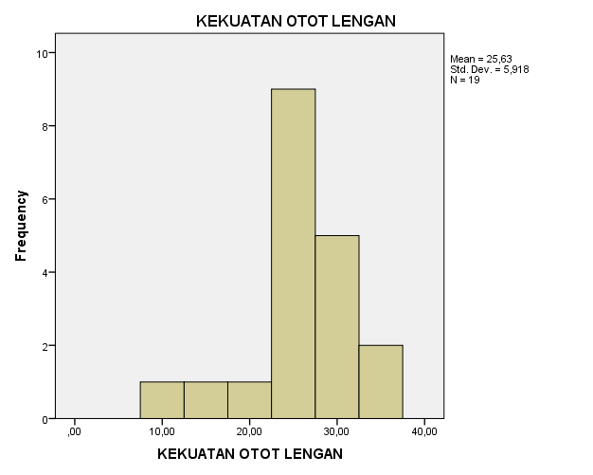

Lampiran 18
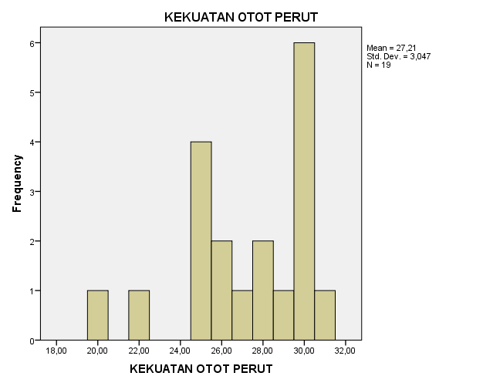
Lampiran 19
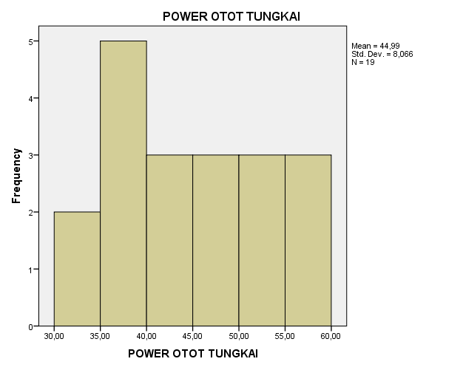
Lampiran 20

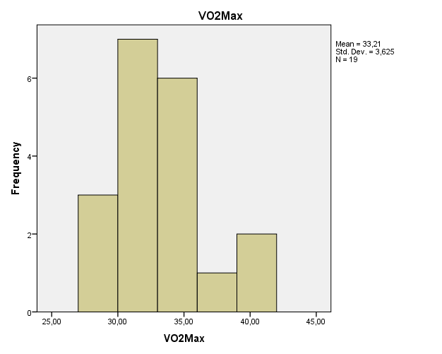
Lampiran 21
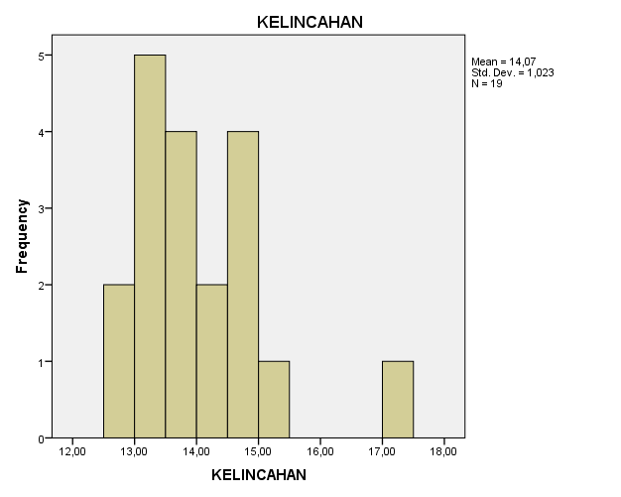
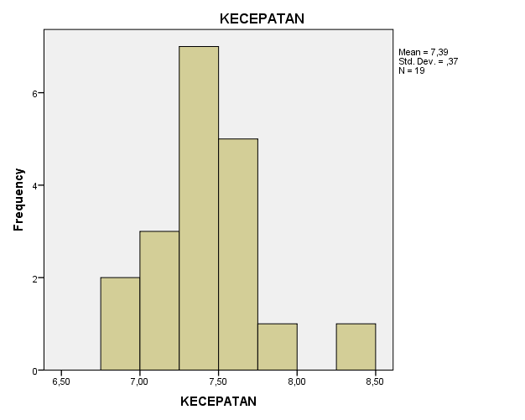
Lampiran 22

