**TEACHING VOCABULARY USING VIDEOS TO THE TENTH GRADE STUDENTS AT SMAN 1 MOJO KEDIRI IN THE ACADEMIC YEAR 2024/2025**

**SKRIPSI**

**Presented as a Partial Fulfillment of the Requirement the**

**Sarjana Degree of Education of English Department**

**Faculty of Teacher Training and Education**

**University of Nusantara PGRI Kediri**



**By:**

**LEA TARISSHA PRIMANDA**

**2114050028**

**ENGLISH EDUCATION DEPARTMENT**

**FACULTY OF TEACHER TRAINING AND EDUCATION** **UNIVERSITY OF NUSANTARA PGRI KEDIRI**

**2024/2025**

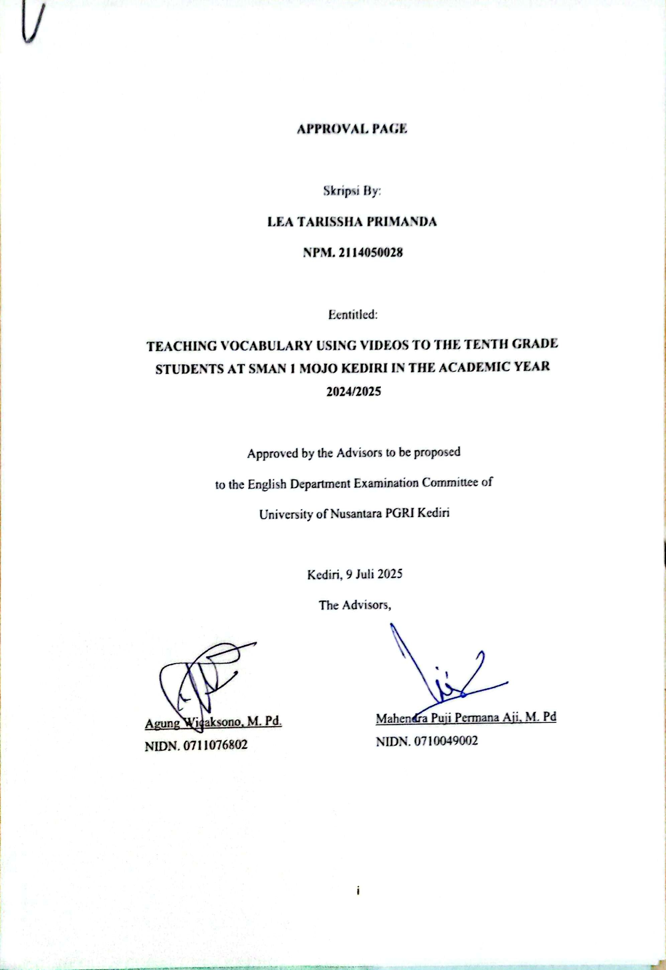

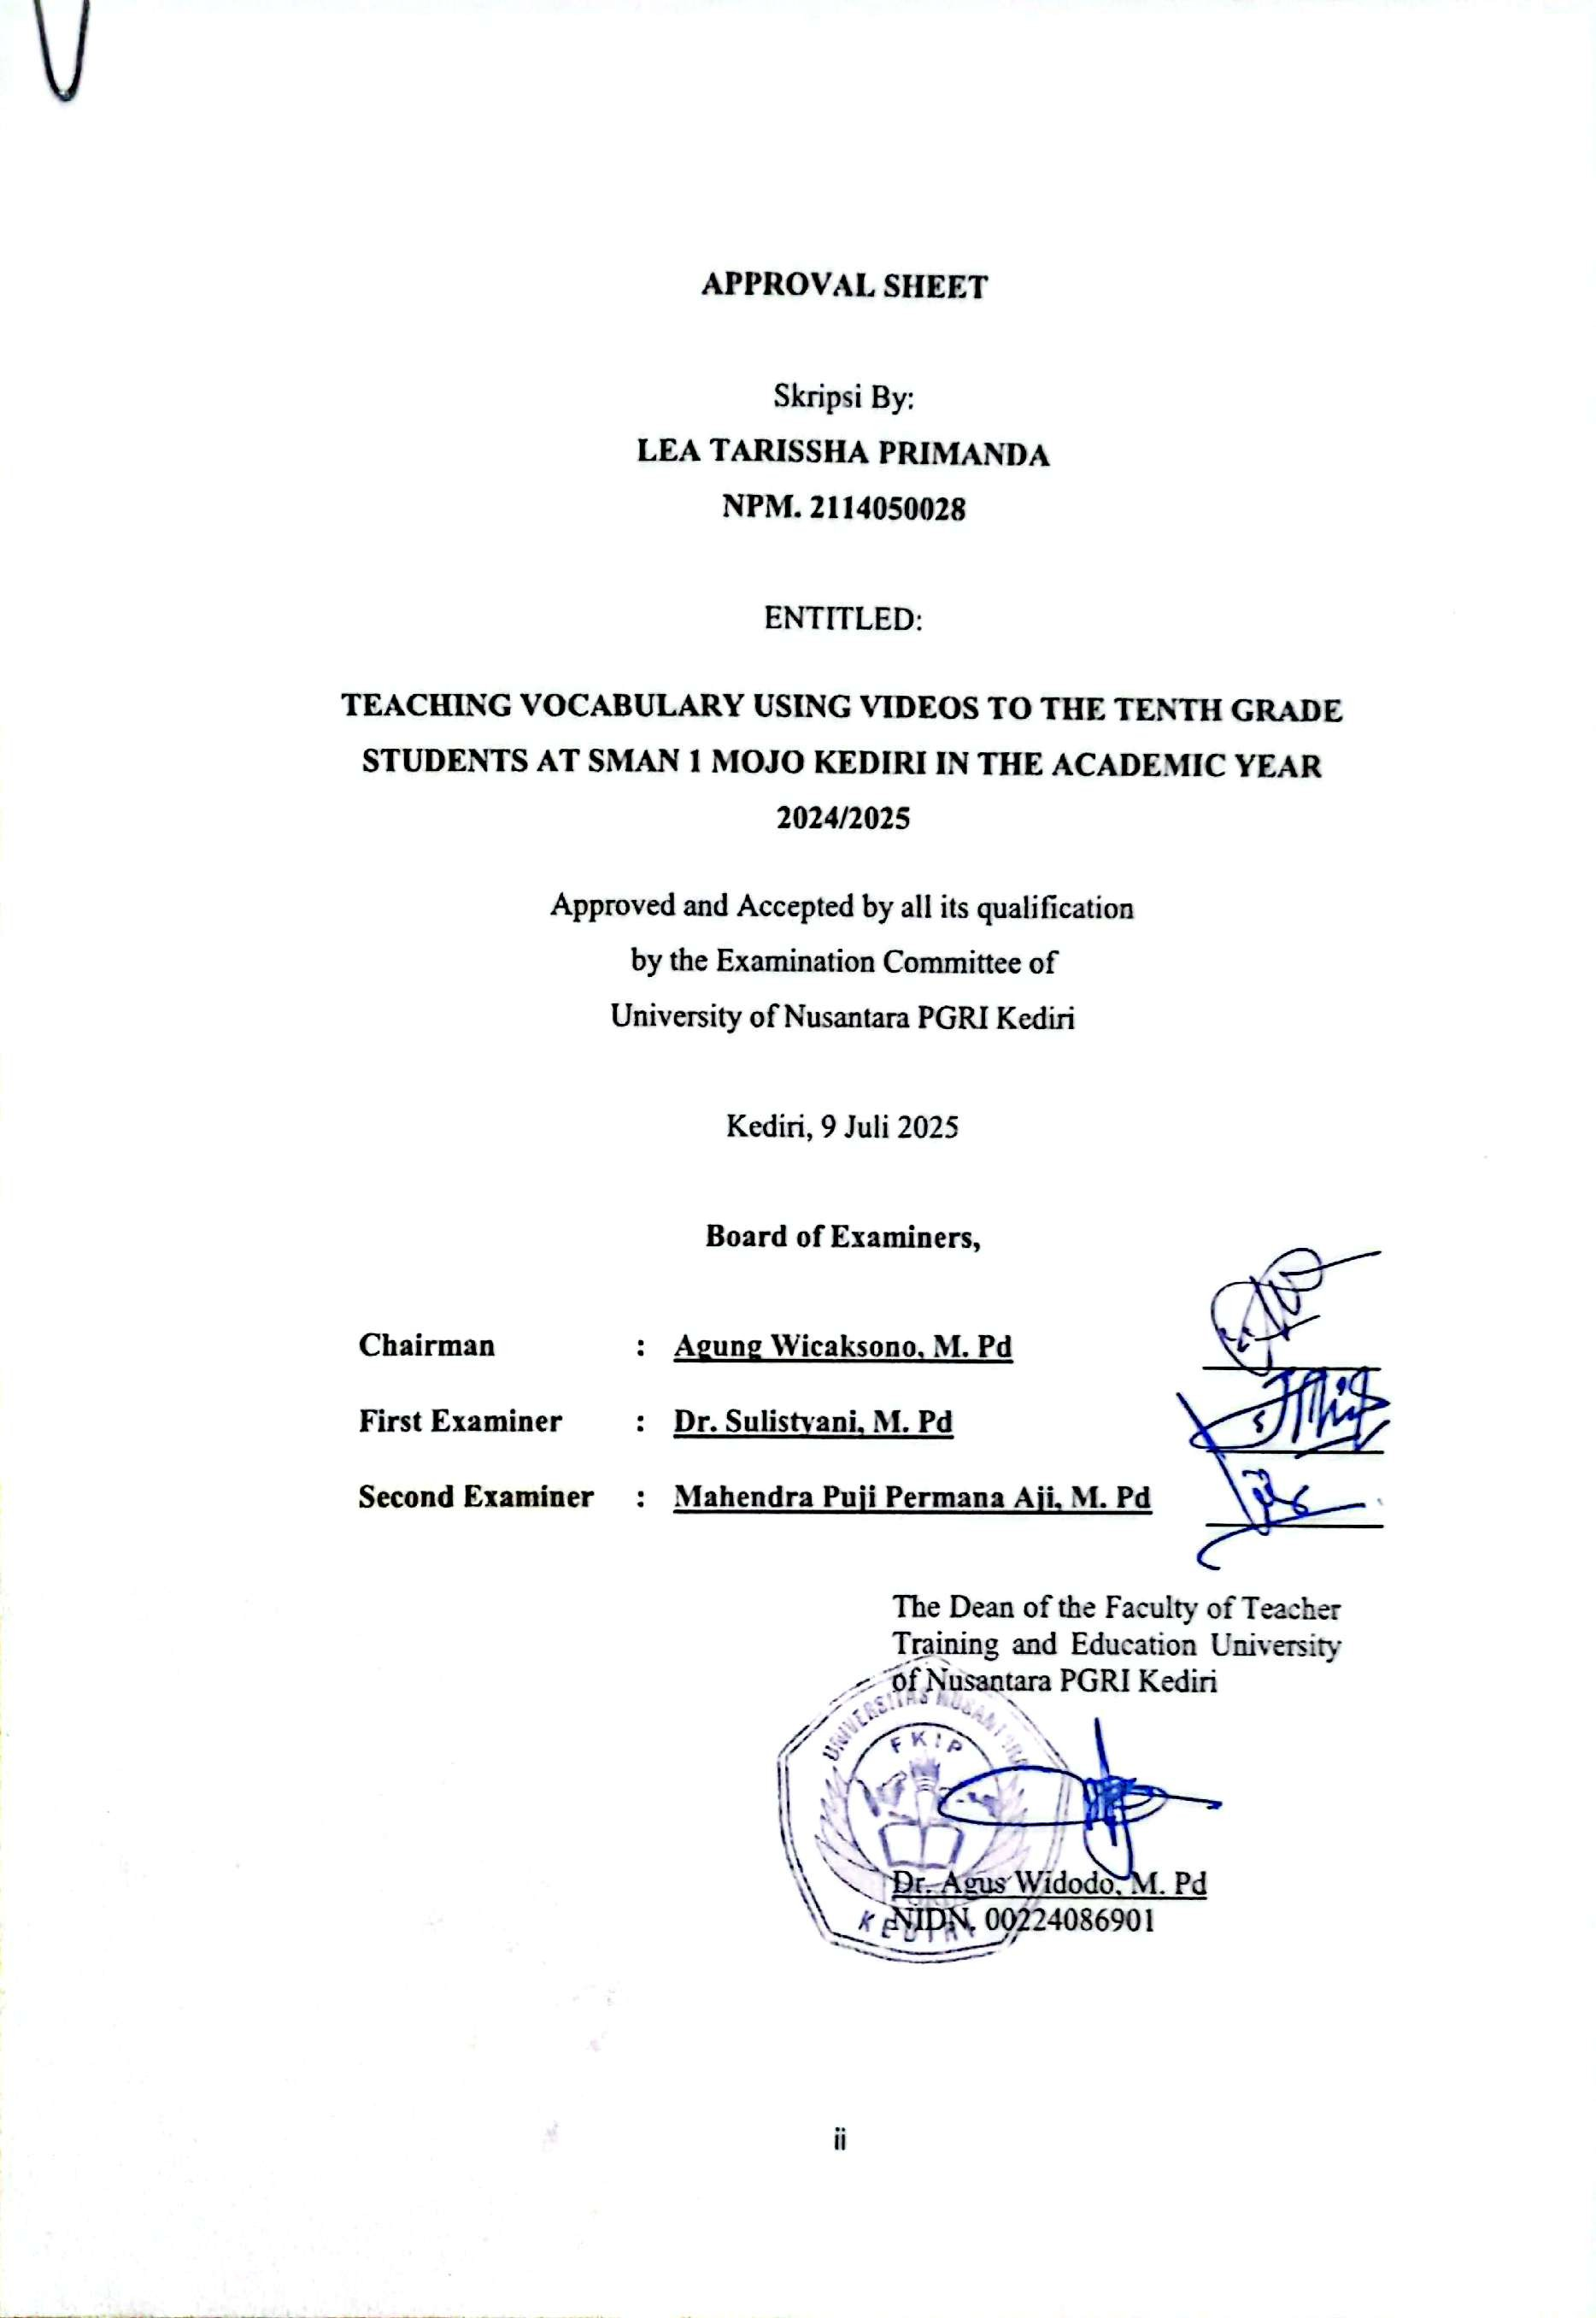

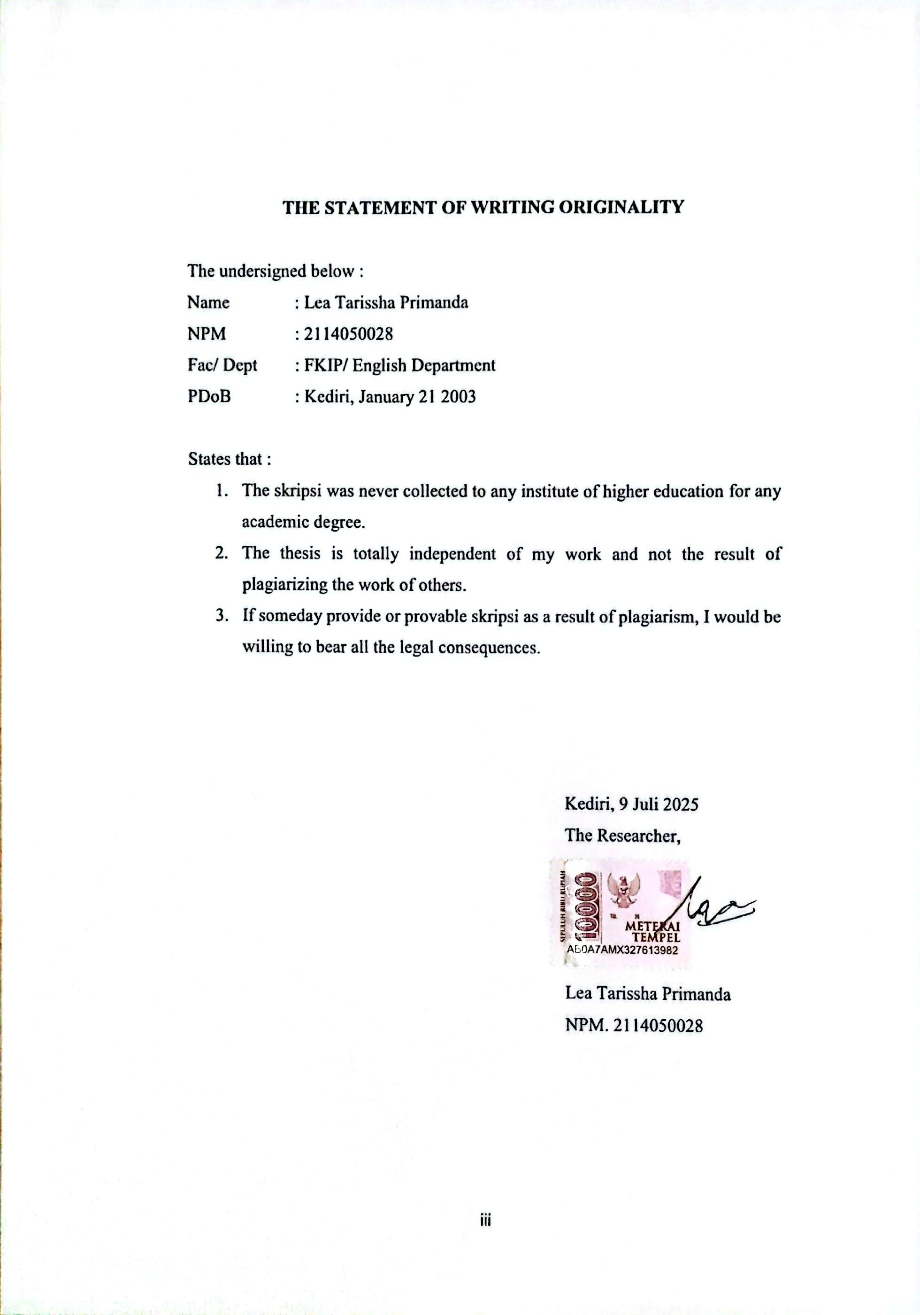

**MOTTO AND DEDICATION**

**Motto:**

*Education is the key that unlocks the doors of imagination, courage,*

*and endless possibilities.*

**Dedicated to :**

1. To my beloved parents, for their endless love, prayers, and unwavering support throughout my academic journey.
2. To my dear friends, Elen, Mara, and Tyas, who have always stood by my side, giving encouragement, laughter, and companionship during every moment of this process.
3. To my beloved partner, M. Ilham Panji Saputra, who has patiently accompanied me through every step of writing this thesis, providing constant motivation, understanding, and love.
4. To all my lecturers and everyone who has supported me, inspired me, and contributed to the completion of this thesis.
5. Finally, I dedicate this thesis to everyone who has contributed to my academic journey. May this work be useful for those who are interested in English language teaching and learning.

**ACKNOWLEDGEMENT**

First and foremost, I would like to express my deepest gratitude to Allah SWT for His blessings and guidance that enabled me to complete this thesis entitled “Teaching Vocabulary Using Videos to the Tenth Grade Students at SMAN 1 Mojo Kediri in the Academic Year 2024/2025.”

I would like to sincerely thanks and appreciation are expressed to:

* + - 1. Dr. Zainal Affandi, M. Pd as Rector of Universitas Nusantara PGRI Kediri for the opportunities and facilities provided throughout my studies.
      2. Dr. Agus Widodo, M. Pd as Dean of the Faculty of Teacher Training and Education for the guidance and support.
      3. Dr. Khoiriyah, M. Pd as Head of the English Education Study Program for academic direction during the learning process and thesis preparation.
      4. Mr. Agung Wicaksono, M. Pd and Mr. Mahendra Puji Permana Aji, M. Pd, as thesis advisors for their valuable guidance, patience, and encouragement throughout the research and writing process.
      5. Mr. Arif Syah Putra, M. Pd as Principal of SMAN 1 Mojo Kediri for granting permission and facilities during the research.
      6. Mrs. Dewi Ni’matin, S. Pd as English teachers of SMAN 1 Mojo Kediri for their assistance and support during the research activities.
      7. I am also thankful to all lecturers and staff of the English Education Department, Universitas Nusantara PGRI Kediri, for their knowledge and support during my studies.

Once again, I would like to extend my heartfelt appreciation to everyone who has supported me throughout this journey. I hope this thesis can contribute positively to the field of English education and inspire further research. I am fully aware that this work is far from perfect, so any constructive criticism and suggestions for improvement are highly welcomed.

**ABSTRACT**

Lea Tarissha Primanda

Teaching Vocabulary Using Videos to the Tenth Grade Students at SMAN 1 Mojo Kediri in the Academic Year 2024/2025

English Education Department, Faculty of Teacher Training and Education, University of Nusantara PGRI Kediri

This research aims to describe the implementation of video in teaching vocabulary to the tenth grade students at SMAN 1 Mojo Kediri in the academic year 2024/2025. Vocabulary is a fundamental aspect of language learning, serving as the foundation for communication in listening, speaking, reading, and writing. However, many students face difficulties in mastering and retaining new vocabulary due to the lack of engaging and motivating learning media, as well as the absence of sufficient opportunities or platforms to practice and apply the vocabulary they have learned. This problem which highlights the importance of social interaction and active practice in learning, where learners build knowledge through experience and direct application. Additionally, Multimedia Learning Theory supports the use of media that combine visual, auditory, and contextual elements, like videos, to improve students’ understanding and memory retention. Therefore, videos are believed to enhance students’ motivation, participation, and comprehension in vocabulary learning.

This research employs a qualitative descriptive method because it aims to provide a detailed description of how video is implemented in vocabulary teaching, focusing on the processes, interactions, and experiences in the classroom rather than quantifying results. This approach allows the researcher to capture the richness of the teaching and learning activities, including students' responses and teacher strategies, in their natural setting. The subjects were tenth grade students of SMAN 1 Mojo Kediri, chosen purposively because they are the learners directly involved in the vocabulary learning using video. The selection was based on their active participation in the class and their relevance to the research focus. Data were collected through field notes and documentation. The findings show that the use of video media in vocabulary teaching creates a more interactive and enjoyable learning environment. Teachers select relevant videos, guide students to focus on new vocabulary, and integrate activities such as pronunciation practice, discussions, and quizzes. Students respond positively, showing increased enthusiasm, confidence, and better retention of new words.

In conclusion, video is effective in vocabulary learning. It is recommended that teachers utilize videos more creatively and integrate interactive activities to maximize learning outcomes.

**Keywords:** video-based learning, vocabulary teaching, speaking skills, announcement, senior high school

**TABLE OF CONTENT**

**COVER PAGE**

**APPROVAL PAGE i**

**APPROVAL SHEET ii**

**THE STATEMENT OF WRITING ORIGINALITY iii**

**MOTTO AND DEDICATION iv**

**ACKNOWLEDGEMENT v**

**ABSTRACT vi**

**TABLE OF CONTENT viii**

**LIST OF APPENDICES x**

**CHAPTER I**

**INTRODUCTION 1**

**A.Background of the Research 1**

**B.Scope of the Problem 3**

**C.Research Question 4**

**D.Objective of the Research 4**

**E.Significance of the Research 4**

**F. Definition of Key Term 5**

**CHAPTER II**

**REVIEW ON RELATED LITERATURE 7**

1. **Theoretical Framework 7**
2. **Vocabulary 7**
   1. **Definition of Vocabulary 7**
   2. **Type of Vocabulary 8**
   3. **The Importance of Vocabulary 9**
   4. **The Role of Vocabulary in Language Learning 10**
3. **Teaching Vocabulary 10**
   1. **Teaching Vocabulary 10**
   2. **The Role of Teacher to Teaching Vocabulary 12**
4. **Media 13**
   * 1. **Type of Media 13**
     2. **MALL (Mobile Assisted Language Learning) 16**
5. **Video 19**
6. **Teaching Vocabulary Using Video 19**

**B. Review of Related Research. 22**

**CHAPTER III**

**RESEARCH METHOD 24**

**A. Type of Research 24**

**B. Role of the Researcher 24**

**C. Research Stages 25**

**D. Place and Time of the Research 27**

**E. Source of Data 27**

**F. Procedure Collection of the Data 28**

**G. Techniques Data Analysis 28**

**H. Validation 29**

**CHAPTER IV**

**RESEARCH RESULT AND DISCUSSION 31**

**A. Data Description 31**

**B. Research Findings 31**

**C. Discussion of Research Findings 35**

**CHAPTER V**

**A. Conclusion 37**

**B. Suggestion 37**

**REFERENCES 39**

**LIST OF APPENDICES**

**Appendix 1 40**

**Appendix 2 46**

**Appendix 3 47**

**Lembar Persetujuan Skripsi 48**

**Berita Acara 49**

**Surat Penelitian 51**

**CHAPTER I**

**INTRODUCTION**

1. **Background of the Research**

Vocabulary is important for every language learning. Vocabulary plays an important role in foreign language acquisition because it is the basis of communication in listening, speaking, reading and writing. It is used to express oneself effectively, accurately and precisely. This shows that language learning must be honed continuously to improve skills in conveying and expressing something. Without adequate vocabulary, a person will have difficulty conveying what is on his mind so that it can hinder his ability to communicate daily.

According to Carter (2013: 4) "vocabulary is the total number of words in a language. It's also a collection of words a person knows and uses in speaking and writing". Vocabulary, usually developed with age, serves as a useful and fundamental tool for communication and acquiring knowledge. The lack of a platform to channel their vocabulary skills is one of the factors that makes it difficult for them to communicate using the vocabulary they have learned. Apart from that, they also forget easily because it doesn't happen again when they communicate. Therefore, teachers try to remember the vocabulary they learn by changing the learning medium to use videos.

In the current era, the use of videos in learning has become a medium that is often used by teachers in delivering their material, one of which is language learning on vocabulary material. Video presents movement, color, and sound that can realize ideas better than other media. This media is proven to show significant potential to increase students' interest in learning English vocabulary. For example, videos can provide students with real examples of language use, making it easier for students to understand and remember newly learned vocabulary. In addition, videos can be used to showcase content that students find interesting and fun so as to increase motivation and participation in the learning process. One of the most commonly used videos to teach vocabulary is animated videos. This approach is in line with multimedia learning principles, which suggest that combining text, visuals and audio improves comprehension and memory to create an engaging and interactive learning experience. Teachers can show animated videos or short videos from platforms such as YouTube that match the learning theme, so that students can listen to movements, sounds and visuals that support the understanding of new vocabulary in a contextualized way. During this process, teachers can invite students to repeat the pronunciation of words, imitate intonation, and understand the meaning through discussion activities after watching the video. Teachers can also integrate interactive activities such as quizzes or pronunciation exercises based on the video, so that students actively participate and strengthen their memory of the vocabulary learned. Here the author is interested in conducting research on vocabulary teaching in senior high school because the research is still rare (neglected).

The author is amazed at the teaching innovation of using video methods in vocabulary learning in this school. The use of videos is not just a supporting medium, but has become a very effective bridge in connecting theory with real practice in the classroom. Through attractive visuals, clear sound, and interactive animation, students are not only passively receiving information, but are also actively involved in the learning process. This method is able to liven up the learning atmosphere, making previously abstract vocabulary easier to understand and remember. In addition, videos provide opportunities for teachers to accommodate students' various learning styles, whether visual, auditory or kinesthetic, making learning more inclusive and fun. I was really impressed how teachers can utilize this technology to increase student motivation and participation, making foreign language learning no longer boring, but full of passion and creativity.

In vocabulary learning, videos can be used to present new vocabulary, provide context to the vocabulary and encourage students to practice their pronunciation and meaning. Videos can also be used to create interactive activities such as quizzes to help students improve their understanding of comprehension. So the use of videos in learning can support the development of students' skills.

1. **Scope of the Problem**

Teaching vocabulary using video, particularly for announcement speaking skills, represents a significant innovation in language education. Video functions not only as an engaging learning medium but also creates a dynamic, interactive, and contextual classroom environment. Through video, students can observe, listen to, and imitate pronunciation and vocabulary use in authentic situations, making it easier for them to comprehend and remember new words relevant to oral announcements.

The process begins with careful preparation. The teacher develops a lesson plan (Modul Ajar), selects appropriate videos, and prepares the materials by downloading videos that align with the lesson objectives. This ensures that the content is relevant and supports the learning goals. During instruction, videos—especially animated or YouTube-based clips—significantly boost student engagement, motivation, and interest. Students become more enthusiastic, active, and confident in practicing speaking, even with material that was previously considered challenging or uninteresting.

Video-based announcement materials provide real and contextual examples, enabling students to understand vocabulary usage directly in everyday communication scenarios. This strengthens both their comprehension and retention of new vocabulary. Additionally, videos allow students to mimic native speakers’ pronunciation, intonation, and expressions, resulting in notable improvements in their speaking abilities, particularly in delivering announcements.

Teachers can further integrate interactive activities such as discussions, quizzes, and video-based pronunciation exercises, which have been shown to enhance learning outcomes and make the process more enjoyable. At the end of the lesson, evaluation is conducted using tests to measure students’ vocabulary mastery and speaking performance, ensuring that learning objectives are achieved.

Overall, using video in teaching vocabulary for announcement speaking skills is not only effective but also provides a memorable and transformative learning experience. This approach addresses the challenges of language learning in the digital era and equips students with practical, real-world speaking skills.

1. **Research Question**

This research was conducted because the use of video as a medium for teaching vocabulary in speaking classrooms is still rarely explored. As technology advances, videos—especially those from platforms like YouTube—offer easy access, a variety of content, and a more contextualized learning experience for students. Therefore, the following research question arises: "How is video implemented in vocabulary teaching in the speaking classroom?"

1. **Objective of the Research**

To describe the use of video in teaching vocabulary in speaking classes is the main objective of this study. Vocabulary in this context includes meanings and pronunciation to speaking skills. Particularly the language and expressions used in delivering announcements. Videos provide rich, contextual examples that help students understand how to use vocabulary appropriately in real-life announcement situations, enhancing both their comprehension and speaking performance.

1. **Significance of the Research**

The most interesting part of this research is how teaching vocabulary using videos can increase student engagement and to improve students' vocabulary skills. Learning vocabulary using videos offers several benefits across various stakeholders:

**a. For Teachers:**

* 1. It is easier for teachers to deliver vocabulary material in a more interesting and effective way, because videos provide visual and audio contexts that facilitate student understanding.
  2. Teachers can utilize videos as a variety of learning media to increase student participation and motivation in the classroom.
  3. The use of videos helps teachers create a more lively and interactive learning atmosphere, and reduce students' boredom with conventional methods.

1. **For Students:**
   1. Students find it easier to understand and remember new vocabulary because videos present examples of word usage in real situations, complete with visuals and sound.
   2. Vocabulary learning with videos makes students more enthusiastic, active and confident in the learning process.
   3. Students tend to feel happier and less bored, so their learning motivation increases and learning outcomes are better.
2. **For Researchers**
3. This study provides a scientific contribution regarding the effectiveness of using videos in teaching vocabulary, especially at the senior high school level.
4. The results of the study can serve as a reference for future studies that want to develop technology-based learning media.
5. The researcher gained empirical experience in applying and evaluating video media for vocabulary learning, which can be used for the development of teaching methods in the future.
6. **Definition of Key Term**
7. Vocabulary

Vocabulary is one of the basic aspects of language that must be mastered before mastering English language skills. Vocabulary is all the words that a person knows or uses and are all the words in a particular language. According to Hatch and Brown (1995: 1) vocabulary is a list or collection of words for a particular language or a list or collection of words that may be used by speakers of a particular language.

1. Video

Video is a technology that combines moving images with sound, typically in color, to create an audiovisual experience. It captures and displays a sequence of images at a high rate of frames per second, creating the illusion of motion. Video can be recorded, broadcast, or streamed electronically.

1. Teaching Using Video

Video is considered as an effective aid used by teachers in teaching vocabulary. As mentioned by Hemei (1997), being a rich and valuable resource, video is well-liked by both students and teachers. Teachers use video because it provides rich features such as text, picture, and sound that can attract learners’ interest and helps teachers in teaching learning activities.

**REFERENCES**

Anderson, R. C., & Freebody, P. (1981). Vocabulary knowledge. In J. T. Guthrie (Ed.), Comprehension and teaching: Research reviews (pp. 77-117). International Reading Association.

Carter, R. (1998). Vocabulary: Applied Linguistic Perspectives. London: Routledge.

Kramsch, C. (1993). Context and culture in language teaching. Oxford University Press.

Laufer, B. (1997). The lexical plight in second language reading: Words you don’t know, words you think you know, and words you can’t guess. The Modern Language Journal, 81(2), 158–163.

Laufer, B., & Goldstein, Z. (2004). Vocabulary acquisition in a second language: Do learners really acquire most vocabulary by reading? Some empirical evidence. The Canadian Modern Language Review, 61(3), 567-587.

McCarthy, M. (1990). Vocabulary. Oxford University Press.

Nation, I. S. P. (2001). Learning vocabulary in another language. Cambridge University Press.

Richards, J. C. (1976). The role of vocabulary teaching. TESOL Quarterly, 10(1), 77-89.

Richards, J. C., & Renandya, W. A. (2002). Methodology in language teaching: An anthology of current practice. Cambridge University Press.

Schmitt, N. (2000). Vocabulary in language teaching. Cambridge University Press.

Thornbury, S. (2002). How to teach vocabulary. Pearson Education.

Wilkins, D. A. (1972). Linguistics in language teaching. Edward Arnold.